Master’s Research Project Proposal:
A web-based interactive decision tree using 3D animation question choices as an assessment to test the common misconception of random molecular processes for undergraduate biology students.

6/12/2015
Author: Erina He
Supervisor: Jodie Jenkinson
Content Advisor: Gael McGill
Second Voting Member: Michael Corrin
Introduction:
Science is a subject where the understanding of it builds on itself, a lack of understanding at one level can be crippling for the student on the next. Formative assessments are critical in science education in that not only can we use them as a way to quantitate education progress of students, but they are often the only way we receive feedback to revise classroom instruction (Bell 2002.) Biological concepts, particularly ones dealing with molecular processes are proving to be a challenge to assess with the current method of testing. However, understanding the randomness of biological processes is key to understanding most other biological concepts.

Studies have shown external representations and visualizations are essential in understanding biological processes at an invisible level (Schonborn 2006.) However based off my findings, existing visualizations in current assessment tools are not only rare, they are also inconsistent and confusing for viewers. Combined with highly abstract concepts that are difficult to grasp, current visualizations, most of which are static, are not necessarily an accurate way to reflect to show what students are understanding.

With effective visualization, we can assess our students in a more comprehensive manner for their understanding of biological concepts especially in molecular processes. Animation and information scaffolding are some of the devices that can be applied to the design of current assessments.
Abstract:
The creation of an adaptive decision tree type assessment using 3D animation can solve two of the problems that most assessments fail to address: 1) by creating effective visualizations, we can test students the problematic concepts of biological sciences in a useful and timely manner. 2) Using an adaptive decision tree, we can further organize the questions in the assessment in a meaningful way for a specific cluster of concepts.

Focusing on one area of biology for the assessment can help to build a framework for the assessments on further topics. Randomness of biological processes is a particularly difficult area for students to understand; however understanding this is essential for the understanding of most biological concepts. Although students understand that biological processes have some sort of randomness, this understanding falls apart under certain conditions. The creation of an effective assessment to explore where students began to fail in their understanding for molecular randomness therefore is necessary.

Literature Review:
Design of current science assessments on molecular processes:
The challenge of understanding of molecular science: although a fast evolving field, concepts are highly complex and abstract (Tibell, 2010). Students have a challenging time understanding these concepts and current science curriculum have a tendency to gear towards rote memorization for learning.
There is a need to shift the focus on “conceptual” and “functional” understanding of undergraduate science. Current biology assessment that touches upon the molecular level are few and shallow. Often these assessments are text heavy or have visuals that are high stylized and static (Figure 1). A group in Cornell University that organized the Biological Concepts Inventory (BCI) created an assessment that tests the common misconceptions in biology (Klymkowsky 2010). However this assessment is short and uses no assisting visuals. There is some attempt on organizing the assessment questions, nonetheless the jump between topics is somewhat jarring. The American Association for the Advancement of Science (AAAS) is another well recognized organization that has created a large bank of well documented questions based on misconceptions in science (Deboer 2008). However, this assessment also suffers from the lack of visualizations.

Students’ difficulties about molecular, evolutionary, and genetics concepts stem from their misunderstanding and misconceptions on molecular randomness (Garvin-Doxas 2008).
While understanding that there is an overall random movement of molecules the student’s perception of it falls apart when biological processes have a “goal” to achieve. These misconceptions tend to be robust because students tend to think biological processes are directional. (Chi 2005)

The Importance of Molecular Visualizations:
The use of visualization in molecular science is important because it is fundamental in understanding the biochemistry curriculum. Studies which incorporated the use of molecular visualization and hands-on lab techniques have already been proven to be successful in upper level biology courses. (Schonborn 2006, White 2002).

Having a strong visual literacy is essential, as the use of graphs, diagrams, molecular models, illustrations, animations have all been shown to aid in the understanding of molecular processes. (Schonborn, 2006.) A number of molecular visualization tools such as RasMol, (http://www.openrasmol.org/) and Jmol (http://www.umass.edu/microbio/chime/pe_beta/pe/protexpl/) aim to increase the molecular literacy of students and have shown favorable results when used (Bateman, 2002.) However, while they help the students understand the molecular structure of what they are studying, the static nature of these visualization tools generally do not facilitate the student’s understanding of a molecular process (McClean, 2005). In contrast, The VisChem project, a tool that helps students understand chemical processes, uses animations and simulations to explain chemistry concepts at a molecular level has been concluded effective.(Tasker, 2014.)

Next-Generation Molecular Workbench is an interactive molecular visualization tool that allows the user to manipulate the molecular environment and see how molecules move with the changes in its parameters. This is one of very few tools that allows the student to track a single molecule as it travels through the environment in a random fashion (Figure 2). However, it is difficult to assimilate highly interactive elements in assessments and make it time efficient.
Animation in Molecular Visualization:
A lack of visualizations might be causing language and visual misinterpretation of current assessments. Visualizations can help students overcome these difficulties, however the visualizations themselves are not without their own problems. If wrongly constructed, they can cause the confusion for the student (Tibell 2010.) For example, the complexity of the visualization poses a problem for different audiences; students tend to favor more complex models where experts prefer simplified schematic representations (Harrison and Treagust, 2000.) However, studies have shown that the learning effects complex visualization are only beneficial for basic concepts (Jenkinson, 2013.) In the same study, narrative animation have shown not to be effective in teaching students the randomness nature of molecular events.

3D animation have been proven to be useful in explaining difficult biological processes at the molecular process (Chang & Linn, 2013.) Studies have been consistent on the effectiveness of information processing via the use of animation (McClean 2005, Mayer 2002.) Animation facilitates the understanding of information by providing additional information that cannot be displayed from static images, which in turn helps the learner to build a stronger mental model (Ainsworth, 2008.)

However animations are not without problems: one of the biggest its drawback is the increased cognitive load students encounter (Lowe 1999). For example, while students with high spatial ability benefits greatly from 3D animations, students with low spatial ability understand less (Huk, 2006). For an animation to be effective, students must be able to extract the relevant information from what they are watching (Lowe 2003.) Visual cues should be introduced to ease the cognitive load and grab visual attention (Carrasco 2011.) Although there is little research on the duration of an animation and relation to its usefulness, one can hypothesize that by reducing the length of the animation, we can expect to alleviate some of the visual load by narrowing to only the most important parts.
Purpose of the interactive decision tree: A look into Computerized Adaptive Learning:
Computerized adaptive testing (CAT) is an assessment method that is administered to students on a computer rather than with pencil and paper. The item-response theory (IRT) is often integrated with CAT, where the questions are generally given to students one at a time and depending on the decision the student picks, a different set of questions follows (for a more in depth explanation of IRT and its uses, see The Item Response Theory, Susan E Embresten, 2013.) The general consensus on the foremost advantage of using IRT-CAT is that it reduces the amount of time taken to assess a student without diminishing its efficiency of assessing his level of knowledge (Guzman 2004, Welch 2003.) Assessment objectives therefore can be narrowed and as specific as desired.

Scaffolding Learning and Adaptive Assessment:
Using adaptive testing is effective testing a group with very different levels of understanding (Wright 2008). Instructional methods built around knowledge construction has in the past proven to help students overcome difficult concepts (Reiser 2004). It has been well documented that learning is facilitated when new knowledge is applicable to existing knowledge (Bransford 2000, Yelland 2007.) Following that train of thought, we can predict that having questions building on top of each other will help the students to better connect what they know. We can predict that a guided assessment that deconstructs the student understanding of molecular interactions can allow us to understand where the misconception stems from.
Research Methods and Evaluation:
Design of molecular questionnaire:
The proposed research project will be a web-based assessment built on top of the current the decision tree that has been created by Jodie Jenkinson, Gael McGill, Stuart Jantzen and Andrea Gauthier (Figure 3). The design of this tree will be changed such that all multiple choices will be short animated clips that are scaffolding at each decision.

Misconceptions about the randomness of molecular processes will be tested in this assessment. Specifically, these questions will focus on protein-receptor binding, and characteristics of the molecular environment. Questions in the decision tree will be reevaluated and reworded so that they will flow better with the visual decisions.

A series of static images similar to Figure 4 will be made as initial visuals for the assessment. These static images will be made to convey what the final 3D animations will look like. Evaluation will be done with a small group of undergraduate biology students to see if the style and idea of the static images are effective in conveying what I intended. Once the initial evaluations for basic visual assessment is complete, I will create 3D animated clips to replace the static images, and adjust the assessment questions in accordance to group feedback.

Design of 3D assets and animations:
Animated clips will be made in MAXXON Cinema 4D or Autodesk Maya. Models of the molecules will be based off existing resources from PDB database (http://www.rcsb.org/pdb/home/home.do) using ePMV. Environment complexity of the animations will be similar to number 4 on Figure 5. To reduce the visual load, the clips will be limited to a duration of <10 seconds, without narration. Color contrast, arrows, and other visual cues will be used to direct viewer’s attention areas of focus.

Design of Web Based Platform:
The animated clips will be exported into a format that can be directly embedded onto the web platform. They will be organized on the platform in a way such that all animated decisions will be displayed at once for each of the question. A confidence bar will also be included on the questionnaire page to gauge how confident the student is about their answer. Each page will only display one questions at a time. The final assessment will contain a total of 20-25 questions separated into 2 distinct categories: 1) the ligand-substrate binding and 2) the molecular environment.

Qualitative evaluation will be made to see how the visual assessment tool performs in comparison to the text based assessment tool. Data will be collected using a php script similar to what was done with the text-based decision tree. Open ended questions will also be included to collect student feedback on how useful the animations felt to them.

Discussion:
There is a need for a better formative assessment for science if we are to improve the way students are taught. The goal of my project is twofold; one to create a more effective formative science assessment that can be used in an undergraduate classroom to test the students’ understanding of a subject; and two, to gauge the students’ overall understanding of molecular processes and where misconceptions arise. While achieving these goals, I aim to create this tool in a manner that can also modified into an instructional tool to correct the misconceptions students have at each level.

Appendix:
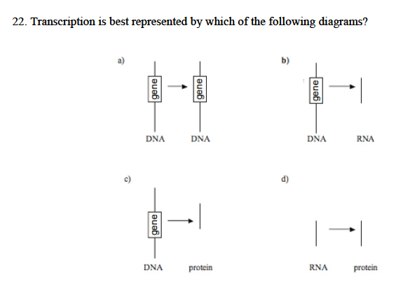
Figure 1. Stylized static imaged used in the Introductory Molecular and Cell Biology Assessment, by Shi et al.

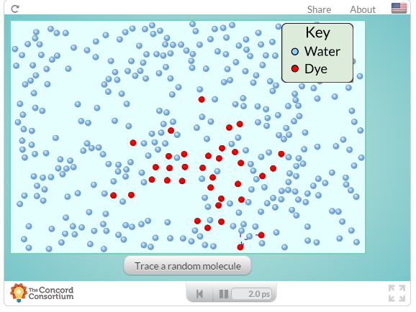

Figure 2. An interactive module from the Molecular workbench showing the movement of certain molecules in diffusion.

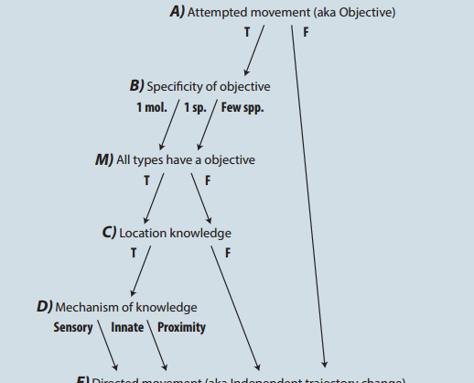
Figure 3. Adaptive decision tree and its questionnaire flow.

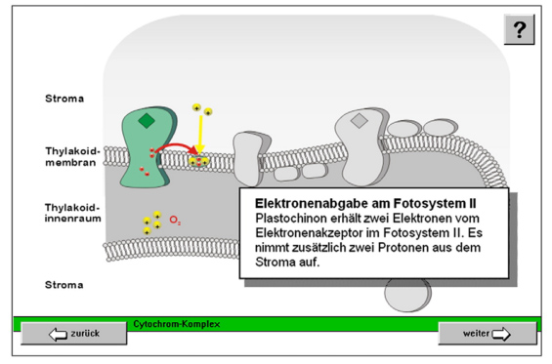
Figure 4. Static image of electron transfer in photosynthesis. Visual cues used in this figure are: color contrast and arrows. (Höffler 2010)

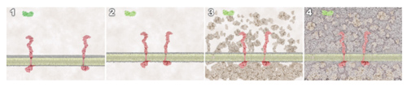
Figure 5. Four depictions of molecular environmental complexity. All four figures show ligand-protein binding. (Jenkinson 2013)

References:
Ainsworth, S. (2008). How do animations influence learning? In D. H. Robinson & G. Schraw (Eds.), Recent Innovations in Educational Technology That Facilitate Student Learning (pp. 37–67). Information Age Publishing.
Bateman, R. C., Booth, D., Sirochman, R., Richardson, J., & Richardson, D. (2002). Teaching and Assessing Three-Dimensional Molecular Literacy in Undergraduate Biochemistry. Journal of Chemical Education, 79(5), 551–552. doi:10.1021/ed079p551
Bell, B., & Cowie, B. (2002). The Characteristics of Formative Assessment. Formative Assessment and Science Education, 12(September 2000), 62–79. doi:10.1007/0-306-47227-9_4
Bransford, J. D., Brown, A. L., & Cocking, R. R. (2000). How People Learn: Brain, Mind, Experience, and School. Committee on learning research and educational practice (Vol. Expanded E, p. x, 374 p.). doi:10.1016/0885-2014(91)90049-J
Carrasco, M. (2011). Visual attention: The past 25 years. Vision Research, 51(13), 1484–1525. doi:10.1016/j.visres.2011.04.012
Chang, H. Y., & Linn, M. C. (2013). Scaffolding learning from molecular visualizations. Journal of Research in Science Teaching, 50(7), 858–886. doi:10.1002/tea.21089
Chi, M. T. H. (2005). Commonsense Conceptions of Emergent Processes: Why Some Misconceptions Are Robust. Journal of the Learning Sciences, 14(2), 161–199. doi:10.1207/s15327809jls1402_1
Deboer, G. E., Abell, C. H., Regan, T., & Wilson, P. (2008). Assessment Linked to Science Learning Goals: Probing Student Thinking Through Assessment. Assessing Student Learning: Perspectives from Research and Practice, (1989), 231–252.
Embretson, S. E., & Reise, S. P. (2013). Item response theory. Psychology Press.
Garvin-Doxas, K., & Klymkowsky, M. W. (2008). Understanding randomness and its impact on student learning: lessons learned from building the Biology Concept Inventory (BCI). CBE Life Sciences Education, 7(2), 227–33. doi:10.1187/cbe.07-08-0063
Guzmán, E., & Conejo, R. (2004). A Model for Student Knowledge Diagnosis Through Adaptive Testing *, 6, 12–21.
Höffler, T. N., Prechtl, H., & Nerdel, C. (2010). The influence of visual cognitive style when learning from instructional animations and static pictures. Learning and Individual Differences, 20, 479–483. doi:10.1016/j.lindif.2010.03.001

Huk, T. (2007). Who benefits from learning with 3D models? The case of spatial ability. (vol 22, pg 392, 2006). Journal of Computer Assisted Learning, 23, 169. doi:10.1111/j.1365-2729.2007.00231.x
Jenkinson, J., & Mcgill, G. (2013). Using 3D Animation in Biology Education : Examining the Effects of Visual Complexity in the Representation of Dynamic Molecular Events. Journal of Biocommunication, 39(2), 42–49.
Klymkowsky, M. W., Garvin-Doxas, K., & Zeilik, M. (2003). Bioliteracy and teaching efficacy: what biologists can learn from physicists. Cell Biology Education, 2, 155–161. doi:10.1187/cbe.03-03-0014
Lowe, R. K. (1999). Extracting information from an animation during complex visual learning. European Journal of Psychology of Education, 14, 225–244. doi:10.1007/BF03172967
Lowe, R. K. (2003). Animation and learning: selective processing of information in dynamic graphics. Learning and Instruction, 13(2), 157–176. doi:10.1016/S0959-4752(02)00018-X
Mayer, R. E., & Moreno, R. (2002). Animation as an aid to multimedia learning. Educational Psychology Review, 14(1), 87–99. doi:10.1023/A:1013184611077
McClean, P., Johnson, C., Rogers, R., Daniels, L., Reber, J., Slator, B. M., … White, A. (2005). Molecular and cellular biology animations: development and impact on student learning. Cell Biology Education, 4(2), 169–79. doi:10.1187/cbe.04-07-0047
NRC (2003a). Improving Undergraduate Instruction in Science, Technology, Engineering, and Mathematics, Washington, DC: National Academies Press. www.nap.edu/catalog.php?record_id?10711
Reiser, B. (2004a). Scaffoldng complex learning: The mechanisms of structuring and problematizing student work. The Journal of the Learning Sciences, 13(3), 273–304. doi:10.1207/s15327809jls1303
Reiser, B. (2004b). Scaffoldng complex learning: The mechanisms of structuring and problematizing student work. The Journal of the Learning Sciences, 13(3), 273–304. doi:10.1207/s15327809jls1303
Schönborn, K. J., & Anderson, T. R. (2006). The importance of visual literacy in the education of biochemists. Biochemistry and Molecular Biology Education, 34(2), 94–102. doi:10.1002/bmb.2006.49403402094
Shi, J., Wood, W. B., Martin, J. M., Guild, N. a, Vincens, Q., & Knight, J. K. (n.d.). Introductory Molecular and Cell Biology Assessment (IMCA), 1–8.
Tasker, R. (2014). RESEARCH INTO PRACTICE : Visualising the molecular world for a deep understanding of chemistry. Teaching Science, 60(2).
The Concord Consotium “Next-Generation Molecular Workbench” Accessed May 9, 2015. http://mw.concord.org/nextgen/

Tibell, L. A. E., & Rundgren, C.-J. (2010). Educational challenges of molecular life science: Characteristics and implications for education and research. CBE Life Sciences Education, 9(1), 25–33. doi:10.1187/cbe.08-09-0055
White, B., Kim, S., Sherman, K., & Weber, N. (2002). Evaluation of Molecular Visualization Software for Teaching Protein Structure. Biochemistry and Molecular Biology Education, 30(2), 130 –136. doi:10.1002/bmb.2002.494030020026
Wright, T., & Hamilton, S. (2008). Assessing student understanding in the molecular life sciences using a concept inventory. ATN Assessment, 8, 216–224.
Yelland, N., & Masters, J. (2007). Rethinking scaffolding in the information age. Computers and Education, 48, 362–382. doi:10.1016/j.compedu.2005.01.010

