APPENDICES.

A. Recruitment materials: Page 2-3
B. Information and consent: Page 4-5
C. General information questionnaire: Page 6-7
D. General Science / Biology Literacy Survey: Page 8-9
E. Molecular Biology survey question list: Page 10-14
F. Feedback form: Page 15
G. References: Page 16
APPENDIX A. Recruitment Forms:
In class: Information Session Script:
Hi, my name is Erina He and I’m a current Biomedical Communications Masters student here at UofT. Being a part of BMC, we investigate different ways to visually communicate with our audience, which hopefully in turn would help create tools to support in your learning experience.
I’m here as a part of an on-going research project that examines the students’ understanding of the molecular world. My research involves with incorporating visualizations in a testing environment, and seeing how it might affect your performance on this assessment. I would like to invite you all as a part of my study, which involves answering a short multiple choice survey.
The study will be open for the next 72 hours and you may complete this at the comfort of your home. It should only take about 20-30 minutes of your time. Your participation is completely voluntary, although I of course would like to encourage all of you to be a part of this study. As an incentive, you will receive a 0.5% bonus increase of your overall mark should you participate and complete the survey. My only request is that you do not use any outside resources, there are no consequences for answering any of the questions right or wrong, you will receive the mark bonus as long you complete the survey. At the end of the survey, there is a short feedback form that you can fill out and let me know how you thought of your experience.
So, if you are still interested, and I hope you all are, the link for this study is at: [link to be determined], you can also access it on your UofT portal announcements for this course. You will be asked to log in with your UTORid and password and digitally sign a consent form. Again, this link will only be active for the next 72 hours, so please keep that in mind.
Thank you for your time! If you have any questions or would like more information about the study, please don’t hesitate to send me an email at: Erina.he@mail.utoronto.ca
Blackboard:
Dear [course name] students,
My name is Erina He, a graduate student at the Institute of Medical Sciences for Biomedical Communications. I gave a brief information session about a study we are running at the start of your lecture earlier this week.
The study is now up and running and we invite you to participate at the following: link: [link to be determined].
You can login with your utorID and password, after which you will be given all the information you need to know about the study in the Informed Consent Form. Please sign up for the study by 11:59am on [insert date].
A 0.5% bonus mark will be rewarded to your final grade in [course name] upon completion of the study.
APPENDIX B. Informed Consent Form:
Invitation:
You have been invited as a part of our research study to evaluate how well students understand molecular processes and interactions. Particularly, we are investigating in how we can effectively gauge in your understanding of molecular movements through the use of visualizations. The insight we gain will be valuable in gaining a better understanding of how we can create more accurate assessment tools in the future. When the study is complete, a summary of the cumulated results and conclusions will be made available to you through the research group’s website www.sciencevis.com, and the research will be submitted for publication in a peer-reviewed journal.
Your Role:
This study is open to English speaking UTM students who are over 18 years of age. We are interested in how you view the molecular world, in particular how you think molecules move and interact its environment. You will be asked to give us a little bit of a background about yourself and take a short molecular survey. Some of you may be prompt look through some animations for the molecular survey before picking an answer choice, this assignment for this task is completely random. All components of this study may be completed online within the next 72 hours. By consenting to participate in this study, you will be asked to:
- Complete a General Information Questionnaire that collects data on your age, gender, and area of study
- Complete a general science and biology literacy survey.
- Complete a multiple choice molecular biology assessment.
The completion of your role should take about 20-30minutes of your time.
Risks/Benefits
Participating in this study will involve approximately 30 minutes of your time (about 20 minutes at the beginning of the semester and 10 minutes at the end of the semester). To compensate you for your time, you will be given a 0.5% bonus toward the final mark in the Biology course associated with this study (BIO152, BIO206, or BIO153, BIO207, decided when schedule is finalized) at the end of the semester. You will receive this bonus upon the full completion of your role for the survey. Your participation and performance in this study will otherwise have no impact whatsoever on your regular course grade in any course at the University of Toronto.
Your participation is completely voluntary. You are free to withdraw from the study at any time without explanation. Should you choose to withdraw from the study you may do so simply leaving test page or by informing the researcher by email (see below) that you would like to be removed from the study.
You are free to contact the Ethics Review Office at ethics.review@utoronto.ca or 4169463273 if you have any questions about your rights as a participant.
Confidentiality
All the information you provide during the session will remain strictly confidential. General information and pre and post-test results will be identified by participant number only. Your name will not be associated in any way with the data analysis. The research team plans to publish the results in an appropriate peer-reviewed journal at the completion of the study. Volunteers will be described in the manuscript as “undergraduate biology students at the University of Toronto Mississauga.” If you have any questions or concerns about participating in this study, please feel free to contact Erina He via email : Erina.he@mail.utoronto.ca

________________________________________(type full name) agree to participate in this study as described above.
I understand that I can withdraw at any time without reason.
I understand that all information gathered will remain confidential.
My participation and performance will not affect my grade in any course, in any way (except for the benefit of a 0.5% bonus mark upon study completion).
I have had this study and the consent form explained to me, and I have been given a copy to keep.
SUBMIT

APPENDIX C. General Information Questionnaire
Please provide the following information about yourself:
1. Gender:
- Male
- Female
- Undisclosed
2. Age: ______
3. In which course are you currently enrolled?
- BIO152 Introduction to Evolution and Evolutionary Genetics
- BIO206 Introduction to Molecular Biology
- BIO372 Molecular Biology
- None of the above
4. What is your major area of study? (Please choose the best suited option)
- Anthropology
- Astronomy
- Biology
- Biology Health
- Sciences
- Biology Paleontology
- Chemistry
- Communication, Culture, Information and Technology
- Earth Sciences
- Economics
- English and Drama
- Language Studies
- Geography
- Historical Studies
- Management
- Mathematical and Computational Sciences
- Philosophy
- Physics
- Political Sciences
- Psychology
- Sociology
- Visual Studies
5. Are you currently undertaking a minor in Biology?
- Biology is my major area of study
- Yes, I’m undertaking a minor in Biology
- No, I’m NOT undertaking a minor in Biology
6. Are you currently specializing in any of the following Biology programs?
- Currently NOT enrolled in any specialist program
- Biology Specialist
- Biotechnology
- Comparative Physiology
- Ecology & Evolution
- Molecular Biology
7. How many years of undergraduate study have you already completed? _____
8. Which Biology courses have you already fully completed? Choose all that apply.
[full list of UTM Biology courses]
9. How many courses are you enrolled in this semester? _____
10. How would you characterize your learning style?
- Visual learner: learns best when information is delivered in auditory formals such as lectures, discussions, oral readings, audio recordings, or podcasts.
- Auditory learner: learns best when information is presented in visual formats such as books, articles, web pages, images, videos, and diagrams
- Kinesthetic learner: learns best when information is conveyed in “hands on” settings such as trade positions, labs, workshops, or participatory classes.

APPENDIX D. General Science / Biology Literacy Survey

Science literacy
01-BA) Antibiotics kill viruses as well as bacteria (T/F)
02-BB) Lasers work by focusing sound waves (T/F)
03-BC) Electrons are smaller than atoms (T/F)
04-BD) The earliest humans lived at the same time as the dinosaurs (T/F)
05-BE) All radioactivity is man-made (T/F)
06-BF) Which travels faster? (Light, Sound)
07-BG) Radioactive milk can be made safe by boiling it (T/F)
08-BH) The continents on which we live have been moving their location for millions of years and will continue to move in the future (T/F)
09-BI) The center of the Earth is very hot (T/F)
10-BJ) The oxygen we breathe comes from plants and algae (T/F)

Bioliteracy (Biology Concepts Inventory)
Question categories
C1 = drift and diffusion (n=2)
C2 = Energetics and interactions (n=2)
C3 = Molecular properties and functions (n=2)
C4 = Genetic behaviour (n=2)
C5 = evolutionary mechanisms (n=2)
C6 = experimental design (n=0)

- (C1-Q1) Many types of house plants droop when they have not been watered and quickly "straighten up" after watering. The reason that they change shape after watering is because...
- Water reacts with, and stiffens, their cell walls.
- Water is used to generate energy that moves the plant.
- Water changes the concentration of salts within the plant.
- Water enters and expands their cells.
- (C2-Q2) In which way are plants and animals different in how they obtain energy?
  - Animals use ATP; plants do not.
- Plants capture energy from sunlight; animals capture chemical energy.
- Plants store energy in sugar molecules; animals do not.
- Animals can synthesize sugars from simpler molecules; plants cannot.
- (C2-Q3) In which way are plants and animals different in how they use energy?
  - Plants use energy to build molecules; animals cannot.
- Animals use energy to break down molecules; plants cannot.
- Animals use energy to move; plants cannot.
- Plants use energy directly, animals must transform it.
- (C5-Q4) How can a catastrophic global event influence evolutionary change?
- Undesirable versions of the gene are removed.
- New genes are generated.
- Only some species may survive the event.
- There are short term effects that disappear over time.
- (C5-Q6) Natural selection produces evolutionary change by ...
- changing the frequency of various versions of genes.
- reducing the number of new mutations.
- producing genes needed for new environments.
- reducing the effects of detrimental versions of genes.
- (C4-Q15) An allele exists that is harmful when either homozygous or heterozygous. Over the course of a few generations the frequency of this allele increases. Which is a possible explanation? The allele ...
- is located close to a favorable allele of another gene.
- has benefits that cannot be measured in terms of reproductive fitness.
- is resistant to change by mutation.
- encodes an essential protein.
- (C3-Q11) What is it about nucleic acids that makes copying genetic information straightforward?
- Hydrogen bonds are easily broken.
- The binding of bases to one another is specific.
- The sequence of bases encodes information.
- The shape of the molecule is determined by the information it contains.
- (C3-Q13) When we want to know whether a specific molecule will pass through a biological membrane, we need to consider ...
- The specific types of lipids present in the membrane.
- The degree to which the molecule is water soluble.
- Whether the molecule is actively repelled by the lipid layer.
- Whether the molecule is harmful to the cell.
- (C4-Q16) In a diploid organism, what do we mean when we say that a trait is dominant?
- It is stronger than a recessive form of the trait.
- It is due to more, or a more active, gene product than the recessive trait.
- The trait associated with the allele is present whenever the allele is present.
- The allele associated with the trait inactivates the products of recessive alleles.
- (C1-Q29) Sexual reproduction leads to genetic drift because …
- there is randomness associated with finding a mate.
- not all alleles are passed from parent to offspring.
- it is associated with an increase in mutation rate.
- it produces new combinations of alleles.
APPENDIX E. Molecular Biology Survey
Question | Thumbnail | Description
A. An extracellular molecule tries to move towards a complementary receptor | 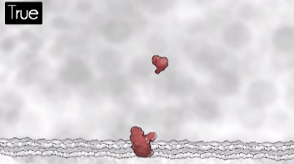 | True  molecule moves in direct math towards reception
 | 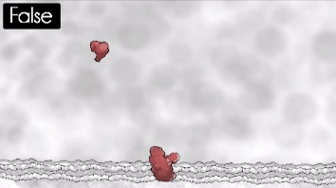 | False  molecule moves in an erratic motion and then off screen.
B. Based on your previous answer and assuming there are several instances of the complementary receptor present, an extracellular molecule tries to move toward: | 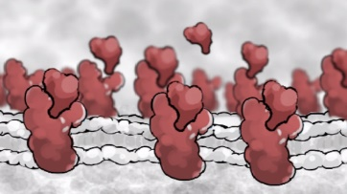 | One specific predetermined instance of the complementary receptor  Use arrows for ligand to choose one receptor it will be binding. Use sequence arrows to show only one path is the true path
 | 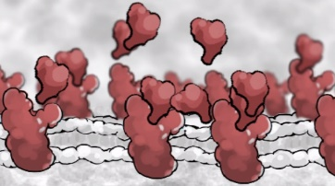 | Any of the complementary receptor instances that are present  Similar to A, but with multiple paths connecting 1 ligand to multiple receptors. Ligand will choose any of them randomly.
 | 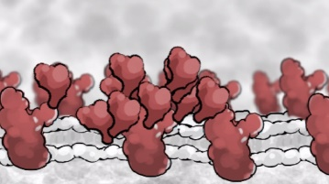 | Whichever instance of the complementary receptor is closest
C. An extracellular molecule knows the physical location of its receptor | 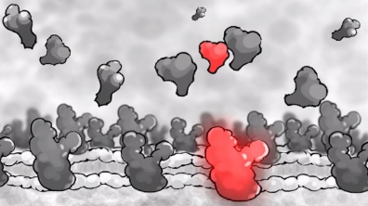 | True  Scene set up to be static. Arrow pinging ligand to receptor.
 | 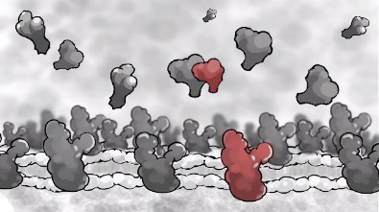 | False  No pinging or glowing effects to indicate any relationship between ligand and receptor
D. Based off your previous answer, how an extracellular molecule know the location of its receptor? | 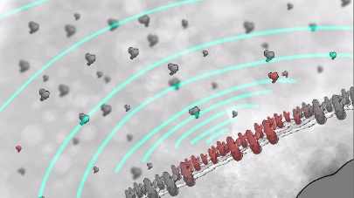 | It can sense the receptor from a distance  Scene setup to be changed to: 1 receptor, 1 ligand. Restrict length of sonar. First sonar waves goes out, misses ligand, nothing happens. Pings again, hits ligand, ligand moves towards receptor.
 | 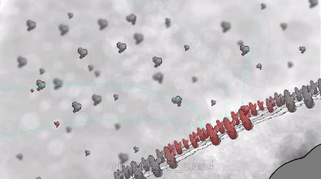 | It has hard-wired knowledge  Scene setup to be changed to: 1 receptor, 1 ligand.
 | 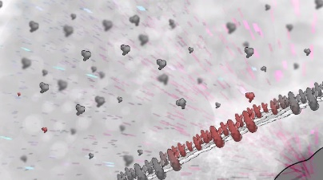 | It receives a message from else where  Signaling comes from nucleus, indicated by arrows.
 | 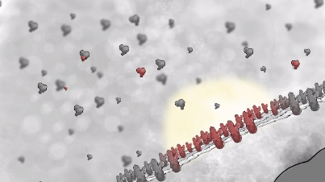 | It can sense the receptor when it is close to it  Glow will be changed to small short sonars.
E. What is the mechanism of an extracellular molecule’s movement towards a receptor | 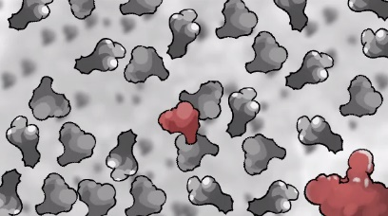 | The extracellular molecule propels itself
 | 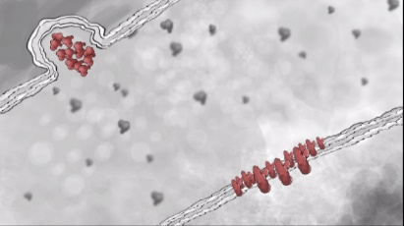 | The extracellular molecule is released from its source with the correct initial trajectory
 | 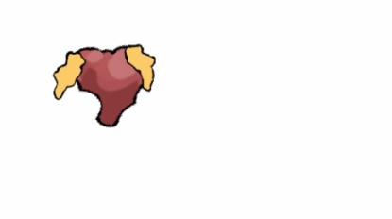 | The extracellular mole uses other helper molecules to be carried closer to the receptor  To be changed to: Mechanism can be more of a “suggested” help instead of actual mechanism. Either small molecules coming to ligand, and then it starts moving in a propelling motion, or receptor subunit will “hook” to ligand and drag it towards itself.
 | 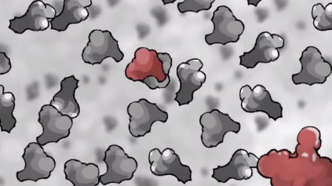 | The extracellular molecule collides randomly with other molecules
F. An extracellular molecule can change direction on its own | 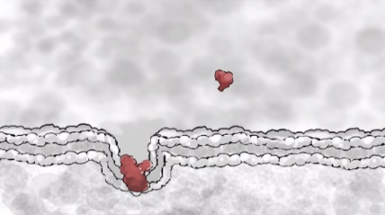 | True  Upon the receptor being revealed to the ECM, ligand abruptly changes path towards it.
 | 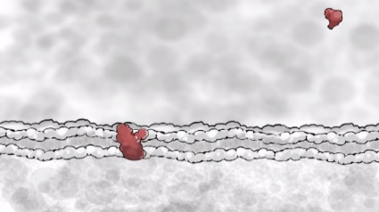 | False  Upon the receptor being revealed to the ECM, the ligand continues moving in its path in Brownian motion.
G. If extracellular molecules move through random collisions, what determines the chance of a binding event occurring between one of these molecules and a complementary receptor? |  | True and False:  This question might be taken out of the assessment due to broad implications. Alternatively, might pin point to a single concept to animate.
H. A large molecule has a more direct path of motion, whereas a small molecule has a more random path | 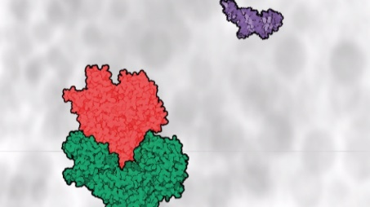 | True  Large molecules move towards each other to bind while small molecules move randomly in the background. Pause or change saturation to draw attention between large and small molecule movement behavior.
 | 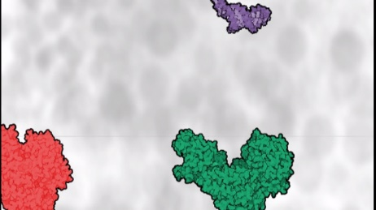 | False  Both large and small molecules move in Brownian motion. Pause or change saturation to draw attention between large and small molecule movement behavior.
I. A molecule’s path of motion is more direct when it has been activated, whereas its path is more random when it is inactive | 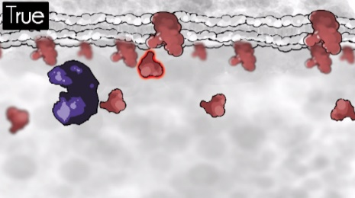 | True  Ligand is activated by enzyme. After activation, ligand moves linearly to receptor.
 | 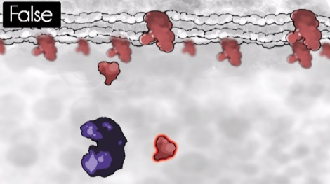 | False  Ligand is activated by enzyme, however after dissociation, still moves in a Brownian motion.
J. Inside a cell, large molecules are densely crowded so much so that the average distance between two macromolecules is typically less than the width of a single macromolecule | 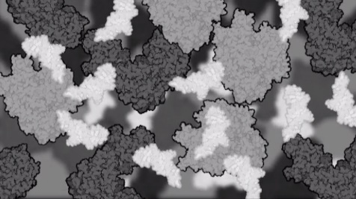 | True  Molecules movie in Brownian motion.
 | 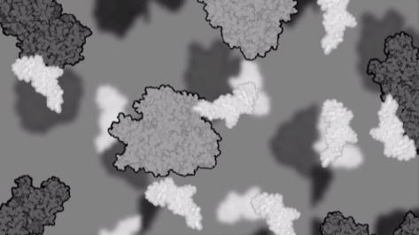 | False  Molecules move in Brownian motion.
K. Inside a cell, empty space is not a factor in the overall direction of diffusion of water and other molecules | 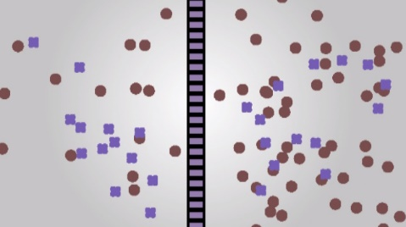 | True  Diffusion occurs in this set up
 | 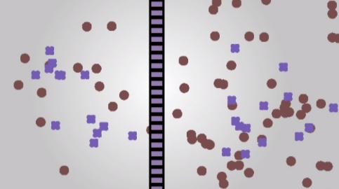 | False  Diffusion does not occur in this set up
L. In the case of simple diffusion across a permeable membrane, once solute molecules reach an equilibrium, they cease to cross the membrane | 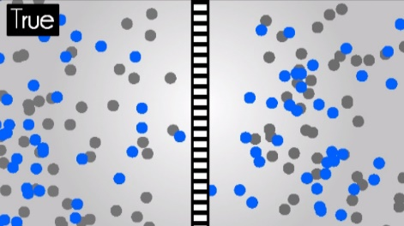 | True  After blue molecules reach equilibrium, they no longer cross the permeable membrane.
 | 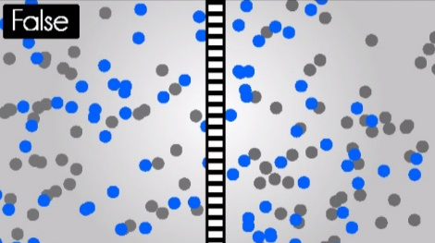 | False  After the blue molecule equilibrium, blue molecules from both sides still cross the membrane freely.
M. A drop of dye is placed in some water. The water, activing as a solvent, diffuses into the dye in the same wat as the dye, acting as a solute, diffuses into the water | 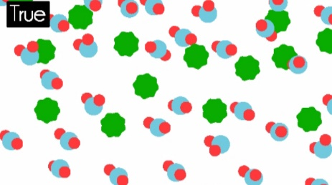 | True  Green molecules move into water molecules as water molecules swarm in green molecules
 | 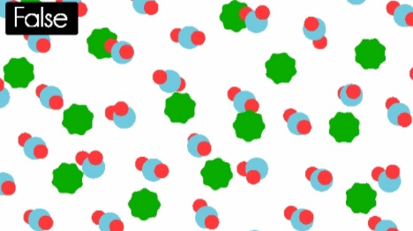 | False  Water molecules do not move, green molecules diffuse into environment around the water molecules
APPENDIX F. Feedback Form
Thank you for participating in our molecular web survey, this portion of the study is optional; however we would greatly appreciate and benefit from any responses from you. Please take a few minutes to answer all or any of these questions.

1. Were there any questions from the molecular survey that you had problems with?

2. Did the visualizations assist or detract you from your decision on any of the questions? If yes to either, which ones stood out for you and how? [Question will only be given to students who had the visualized assessment]

3. Were there any visualizations that differed drastically from what you imagined based off the text? How would you change it? [Question will only be given to students who had the visualized assessment]

4. How did you feel about providing your confidence on responses? Was that difficult to do?

APPENDIX G. References
Ainsworth, S. (2008). How do animations influence learning? In D. H. Robinson & G. Schraw (Eds.), Recent Innovations in Educational Technology That Facilitate Student Learning (pp. 37–67). Information Age Publishing.
Chang, H. Y., & Linn, M. C. (2013). Scaffolding learning from molecular visualizations. Journal of Research in Science Teaching, 50(7), 858–886. doi:10.1002/tea.21089
Bell, B., & Cowie, B. (2002). The Characteristics of Formative Assessment. Formative Assessment and Science Education, 12(September 2000), 62–79. doi:10.1007/0-306-47227-9_4
Chi, M. T. H. (2005). Commonsense Conceptions of Emergent Processes: Why Some Misconceptions Are Robust. Journal of the Learning Sciences, 14(2), 161–199. doi:10.1207/s15327809jls1402_1
Mayer, R. E., & Moreno, R. (2002). Animation as an aid to multimedia learning. Educational Psychology Review, 14(1), 87–99. doi:10.1023/A:1013184611077
McClean, P., Johnson, C., Rogers, R., Daniels, L., Reber, J., Slator, B. M., … White, A. (2005). Molecular and cellular biology animations: development and impact on student learning. Cell Biology Education, 4(2), 169–79. doi:10.1187/cbe.04-07-0047

