Shotname | Question | Thumbnail | Description | Duration | Models
MOL_S001_Q001 | A. An extracellular molecule tries to move towards a complementary receptor | 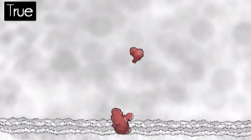 | True, molecule moves in direct math towards reception | 00:00:09 (270f) | One receptor, one ligand. Plasma MB
MOL_S001_Q002 |  | 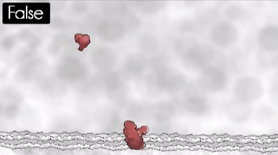 | False, molecule moves in an erratic motion and then off screen. | 00:00:09 (270f) | One receptor, one ligand. Plasma MB
MOL_S002_Q001 | B. Based on your previous answer and assuming there are several instances of the complementary receptor present, an extracellular molecule tries to move toward: | 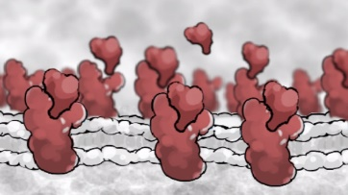 | One specific predetermined instance of the complementary receptor  Text description of choice will be on animation. Use arrows for ligand to choose one receptor it will be binding. Maybe use sequence arrows to show only one path is the true path | 00:00:06 (180f) | One receptor, one ligand. Plasma MB
MOL_S002_Q002 |  | 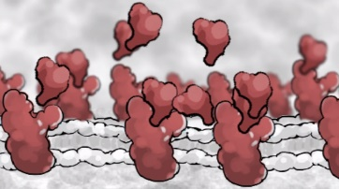 | Any of the complementary receptor instances that are present  Similar to A, but with multiple paths connecting 1 ligand to multiple receptors. Ligand will choose any of them randomly. | 00:00:06 (180f) | One receptor, one ligand. Plasma MB
MOL_S002_Q003 |  | 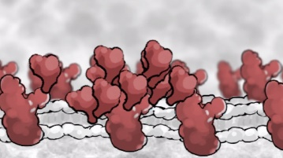 | Whichever instance of the complementary receptor is closest | 00:00:07 (210f) | One receptor, one ligand. Plasma MB
MOL_S003_Q001 | C. An extracellular molecule knows the physical location of its receptor | 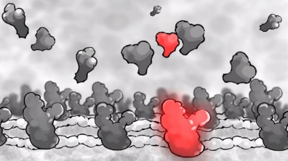 | True  Scene set up to be static. Arrow pinging ligand to receptor. | 00:00:06 (180f) | Two receptor types, two ligand types. Plasma MB
MOL_S003_Q002 |  | 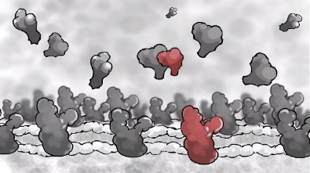 | False  No pinging or glowing effects to indicate any relationship between ligand and receptor | 00:00:06 (180f) | Two receptor types, two ligand types. Plasma MB
MOL_S004_Q001 | D. Based off your previous answer, how an extracellular molecule know the location of its receptor? | 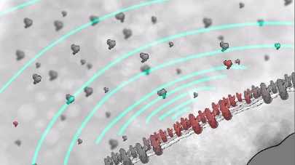 | It can sense the receptor from a distance  Scene setup to be changed to: 1 receptor, 1 ligand. Restrict length of sonar. First sonar waves goes out, misses ligand, nothing happens. Pings again, hits ligand, ligand moves towards receptor. | 00:00:07 (210f) | One receptor, one ligand. Plasma MB, cell nucelus
MOL_S004_Q002 |  | 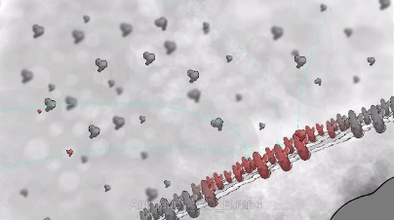 | It has hard-wired knowledge  Scene setup to be changed to: 1 receptor, 1 ligand. | 00:00:07 (210f) | One receptor, one ligand. Plasma MB, cell nucelus
MOL_S004_Q003 |  | 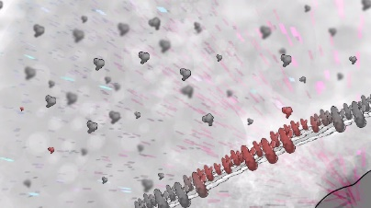 | It receives a message from else where  Signaling comes from nucleus, indicated by arrows. | 00:00:07 (210f) | One receptor, one ligand. Plasma MB, cell nucelus
MOL_S004_Q004 |  | 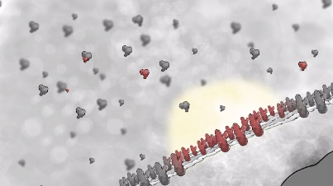 | It can sense the receptor when it is close to it  Glow will be changed to small short sonars. | 00:00:07 (210f) | One receptor, one ligand. Plasma MB, cell nucelus
MOL_S005_Q001 | E. What is the mechanism of an extracellular molecule’s movement towards a receptor | 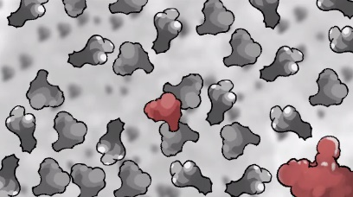 | The extracellular molecule propels itself | 00:00:06 (180f) | Two receptor types, two ligand types.
MOL_S005_Q002 |  | 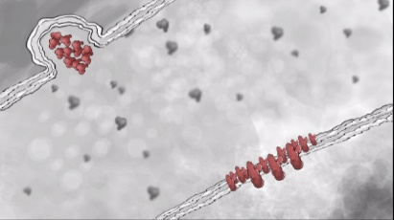 | The extracellular molecule is released from its source with the correct initial trajectory | 00:00:09 (270f) | One receptor, one ligand. Plasma MB
MOL_S005_Q003 |  |  | The extracellular mole uses other helper molecules to be carried closer to the receptor  To be changed to: Mechanism can be more of a “suggested” help instead of actual mechanism. Either small molecules coming to ligand, and then it starts moving in a propelling motion, or receptor subunit will “hook” to ligand and drag it towards itself. | (???) | To be decided
MOL_S005_Q004 |  | 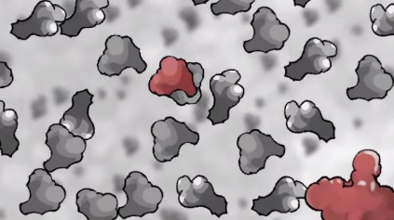 | The extracellular molecule collides randomly with other molecules | 00:00:08 (240f) | Two receptor types, two ligand types.
MOL_S006_Q001 | F. An extracellular molecule can change direction on its own | 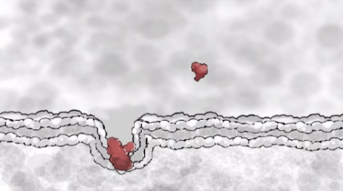 | True  Upon the receptor being revealed to the ECM, ligand abruptly changes path towards it. | 00:00:10 (300f) | One receptor, one ligand. Plasma MB
MOL_S006_Q002 |  | 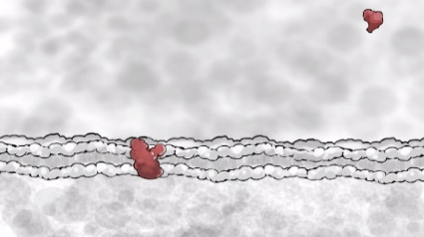 | False  Upon the receptor being revealed to the ECM, the ligand continues moving in its path in Brownian motion. | 00:00:10 (300f) | One receptor, one ligand. Plasma MB
??? | G. If extracellular molecules move through random collisions, what determines the chance of a binding event occurring between one of these molecules and a complementary receptor? |  | True and False: This question might be taken out of the assessment due to broad implications. Difficult to pin point to a single concept to animate.
MOL_S008_Q001 | H. A large molecule has a more direct path of motion, whereas a small molecule has a more random path | 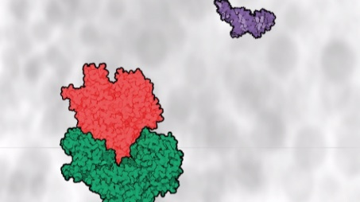 | True  Large molecules move towards each other to bind while small molecules move randomly in the background. Pause or change saturation to draw attention between large and small molecule movement behavior. | 00:00:06 (180f) | 2 enzyme types, small molecules
MOL_S008_Q002 |  | 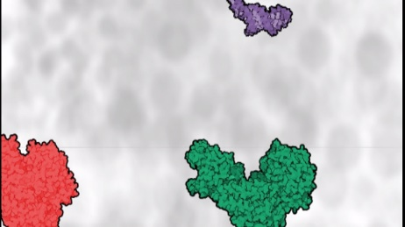 | False  Both large and small molecules move in Brownian motion. Pause or change saturation to draw attention between large and small molecule movement behavior. | 00:00:06 (180f) | 2 enzyme types, small molecules
MOL_S009_Q001 | I. A molecule’s path of motion is more direct when it has been activated, whereas its path is more random when it is inactive | 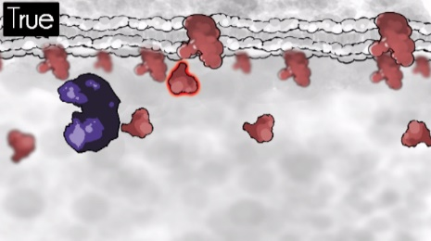 | True  Ligand is activated by enzyme. After activation, ligand moves linearly to receptor. | 00:00:08 (240f) | One receptor, one ligand. Plasma MB, enzyme
MOL_S009_Q002 |  | 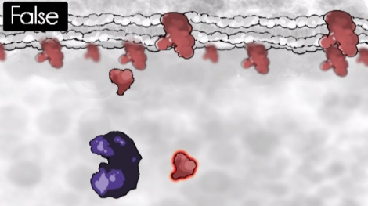 | False  Ligand is activated by enzyme, however after dissociation, still moves in a Brownian motion. | 00:00:10 (240f) | One receptor, one ligand. Plasma MB, enzyme
MOL_S010_Q001 | J. Inside a cell, large molecules are densely crowded so much so that the average distance between two macromolecules is typically less than the width of a single macromolecule | 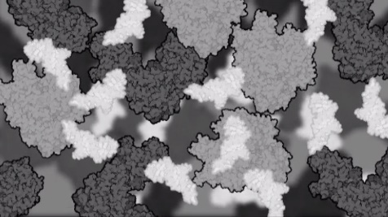 | True  Molecules movie in Brownian motion. | 00:00:09 (270f) | Base off actual cell environment
MOL_S010_Q002 |  | 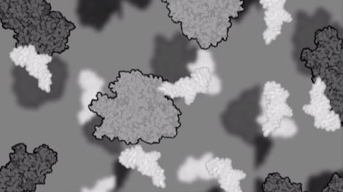 | False  Molecules move in Brownian motion. | 00:00:09 (270f) | Base off actual cell environment
MOL_S011_Q001 | K. Inside a cell, empty space is not a factor in the overall direction of diffusion of water and other molecules | 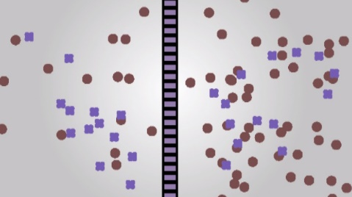 | True  Diffusion occurs in this set up | 00:00:15 (450f) | Semi permeable MB, 2 small molecule types
MOL_S011_Q002 |  | 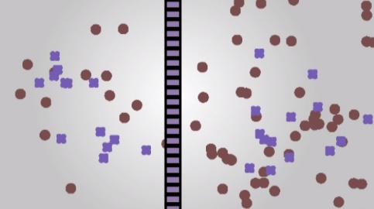 | False  Diffusion does not occur in this set up | 00:00:15 (450f) | Semi permeable MB, 2 small molecule types
MOL_S012_Q001 | L. In the case of simple diffusion across a permeable membrane, once solute molecules reach an equilibrium, they cease to cross the membrane | 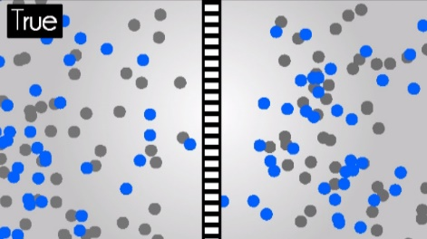 | True  After blue molecules reach equilibrium, they no longer cross the permeable membrane. | 00:00:15 (450f) | Semi permeable MB, 2 small molecule types
MOL_S012_Q002 |  | 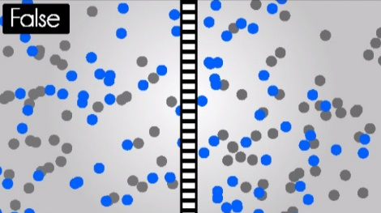 | False  After the blue molecule equilibrium, blue molecules from both sides still cross the membrane freely. | 00:00:15 (450f) | Semi permeable MB, 2 small molecule types
MOL_S013_Q001 | M. A drop of dye is placed in some water. The water, activing as a solvent, diffuses into the dye in the same wat as the dye, acting as a solute, diffuses into the water | 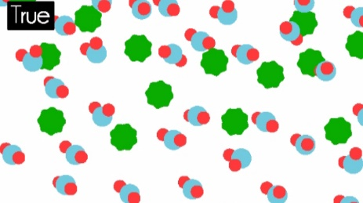 | True  Green molecules move into water molecules as water molecules swarm in green molecules | 00:00:14 (420f) | Water molecule, dye molecule
MOL_S013_Q002 |  | 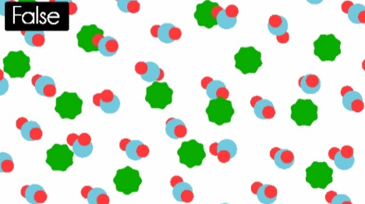 | False  Water molecules do not move, green molecules diffuse into environment around the water molecules | 00:00:14 (420f) | Water molecule, dye molecule

